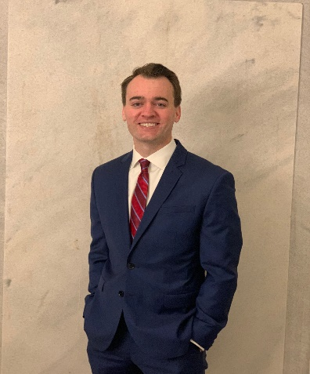 | I have been involved with St. Thomas à Becket for 34 years, having grown up in the parish and, along with my brothers, received all the sacraments of initiation here. I have previously served as a CCD teacher here at the parish as well as having worked at the Chancery on behalf of the Bishop's Lenten Appeal. My faith journey at St. Thomas à Becket has taught me that the most critical and impactful task of any parish is the administration of the sacraments. I am excited to be able to serve the great people of our parish through assisting in this task as a member of the parish council.

